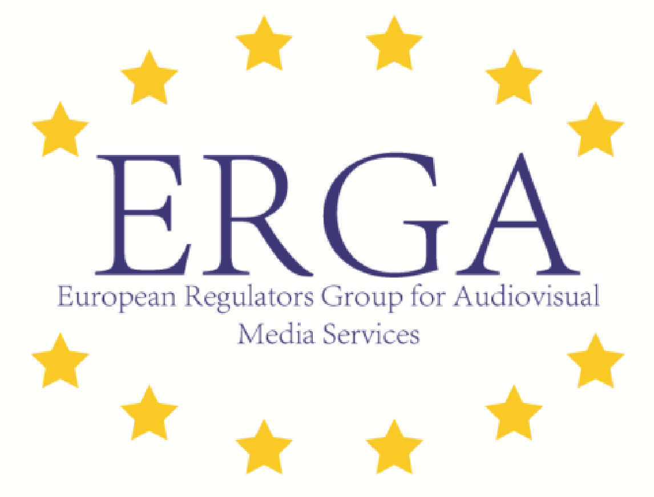
January 11, 2016
Press release of the European Regulators Group for Audiovisual Media Services (ERGA) on the necessity of independent media

Today ERGA publishes a statement on the necessity of independent media, drafted in the light of the recent developments in Poland, as well the ERGA-Report on Independence of the NRA’s.
Poland has introduced legislation on Thursday January 7, 2016 that raises serious concerns on the future independence of Polish public broadcasting organizations. It inter alia deprives the Polish independent National Authority for Audiovisual Media KRRiT, of its power to nominate and dismiss the management of supervisory boards of the public service broadcasters and assigns this power directly to the Minister of State Treasury.
In its statement ERGA welcomes the actions already taken by the European Commission and calls on it to continue to actively monitor developments and to take all necessary steps to support a free and independent media, including the taking of firm action against the weakening of the necessary institutional arrangements.
All EU Member States should uphold the principle of independence of the media. President of ERGA, prof.dr. Madeleine de Cock Buning (Netherlands): “Especially now, we need to underline the crucial role played by the audiovisual media in promoting the free flow of information and ideas to strengthen our democracies by enabling citizens to take decisions with the full knowledge of facts throughout Europe.”
Independent media require the strong shelter of independent oversight against undue state and commercial intervention.
Based on its recent analysis of the position of National Authorities for Audiovisual Media (NRA’s), ERGA publishes today a report to set clear minimum standards for all Member States to ensure independence. The report was established under the ERGA subgroup leadership of the Italian NRA AGCOM and identifies a number of common characteristics that any NRA should be equipped with. Independence both from public authorities and the private sector, accountability to relevant stakeholders, decision-making autonomy, adequate enforcement powers, and sufficient financial resources are crucial for independent oversight of audiovisual media. Above all there should be open and transparent procedures for the nomination, appointment and removal of Board Members of the NRA’s.

According to the President of ERGA, prof.dr. Madeleine de Cock Buning: “this report clearly shows that independent oversight of audiovisual media cannot be taken for granted. Now more than ever action should be taken to ensure that the concept of independence of regulators, already well developed and implemented in other sectors, should also be applied to the sector of audiovisual media.”
With this report ERGA recommends that the upcoming review of the Audiovisual Media Services Directive by the European Commission should include stronger safeguards for the independence of the NRA’s. In the interest of a better protection of our free and democratic societies.
Note for the press: spokesman for the President of ERGA, Joop Veen, can be contacted at 00-31-6-53360029
Link to the ERGA-statement on the necessity of independent media: https://ec.europa.eu/digital-agenda/news-redirect/28183
Link to the ERGA Report on the Independence of the NRA’s: https://ec.europa.eu/digital-agenda/news-redirect/28179

