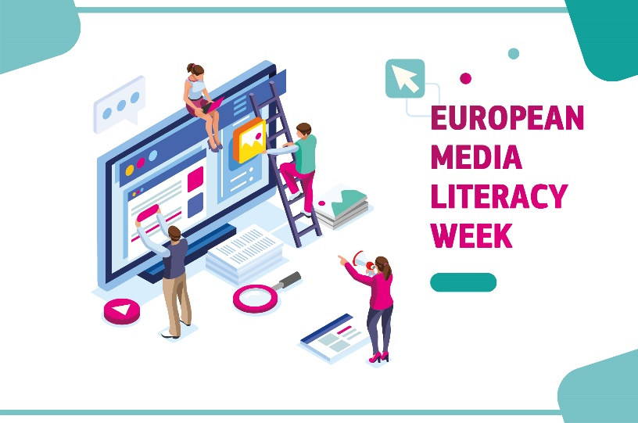 | Media Literacy Awards

- APPLICATION FORM -
INSTRUCTIONS FOR APPLICANTS
Dear applicants for the Media Literacy Awards,

We are looking forward to receiving your submission for the Media Literacy Awards of the European Media Literacy Week. Please make sure you have read all the information provided online in the call for applications, particularly the eligibility criteria and the privacy statement. We also kindly ask you to fill in this form electronically and in the English language. Only complete submission respecting all the eligibility criteria will be considered for the Awards. The call for applications ends on 27 February 2019, 11:59 pm CET.

Please send your completed form via e-mail to the following address (please rename the file according to the following example: “ML Awards 2019_PROJECT NAME”):
CNECT-MEDIA-LITERACY@ec.europa.eu
INFORMATION REQUIRED FROM APPLICANTS

Please fill in the form below with your contact details and the information about the project you are submitting for the Media Literacy Awards.
CONTACT DETAILS:
Full name of the person submitting this application:
Postal address:
Contact e-mail address:
Phone number:
Name of organisation:
Type of organisation:
INFORMATION ABOUT THE PROJECT:
Name of the project:
Media literacy theme and/or skills addressed:
Which audience group(s) does the project target?
How many people (approximately) has your project reached:
Have you undertaken your project in more than one country? If so, in which countries?
Link to webpage or online materials regarding the project:

Please indicate below whether your project fulfils all eligibility criteria of the Media Literacy Awards (select your answer by clicking on the respective box):
Does your project concern mainly the field of media literacy ? | ☐ YES ☐ NO
If you are representing an organisation: Is your organisation established in at least one EU Member State, EEA/EFTA Member State or EU candidate country?  OR:  If you apply as an individual: Are you a citizen or permanent resident of at least one EU Member State, EEA/EFTA Member State or EU candidate country? | ☐ YES ☐ NO
Is your projects directed at a European audience  (EU Member State or EU candidate country)? | ☐ YES ☐ NO
Is the language of your project one of the 24 official languages of the EU or that of an EU candidate country? | ☐ YES ☐ NO
Has the project been undertaken in the last two years (after 1 January 2017)? | ☐ YES ☐ NO

Are you or a representative from your organisation available to present the project during the pitching session for the Media Literacy Awards at the high-level conference of the European Media Literacy Week held in Brussels on 19 March 2019?
☐ YES ☐ NO

PROJECT DESCRIPTION
Please describe the project you are submitting for the Media Literacy Awards in the field below.

We would like to remind you that the finalists for the Awards will be selected based on the following criteria:
- Originality and innovation: how innovative is the media literacy project compared to other initiatives in the field?
- Impact and scalability: the (potential) impact on the intended target groups and the potential of the project to be scaled up to address a wider audience.
- Clarity of presentation: the description is clear and easy to understand.
Please limit the description below to 3000 characters or less (including spaces).
Add your description here…

Please send your completed form via e-mail to the following address by 27 February 2019 11:59 pm CET (please rename the file according to the following example: “ML Awards 2019_PROJECT NAME”):
CNECT-MEDIA-LITERACY@ec.europa.eu
We wish you the best of luck and hope to see you on 19 March 2019 in Brussels!

The revised Audiovisual Media Services Directive defines the concept as follows: “‘Media literacy’ refers to skills, knowledge and understanding that allow citizens to use media effectively and safely. In order to enable citizens to access information and to use, critically assess and create media content responsibly and safely, citizens need to possess advanced media literacy skills. Media literacy should not be limited to learning about tools and technologies, but should aim to equip citizens with the critical thinking skills required to exercise judgment, analyse complex realities and recognise the difference between opinion and fact. […]” (Recital 59 of Directive (EU) 2018/1808 of the European Parliament and of the Council of 14 November 2018: https://eur-lex.europa.eu/eli/dir/2018/1808/oj).
https://europa.eu/european-union/topics/multilingualism_en.

